**Recommendation System Report**

* Rule-Based Recommendation System Using Association Rule-Based Method:

The purpose of this report is to provide a detailed description of the process of constructing a rule-based recommendation system by utilizing the association rule-based method. The purpose of this system is to provide users with personalized recommendations that are generated based on the preferences they have expressed as well as the data they have accumulated in the past. The study delves into a variety of topics, such as the importing of libraries, the preprocessing of data, the construction of models, and the production of the final output. The association rule-based method provides a versatile and interpretable approach to recommendation systems, which enables businesses to make individualized recommendations to the users that use their services.

1.This report will begin by introducing the concept of recommendation systems, which have rapidly become an essential component of a variety of online platforms. These systems make it possible to provide individualized user experiences and boost overall consumer satisfaction. These systems examine the data provided by users and make suitable suggestions and recommendations based on their findings. In this study, we investigate a rule-based recommendation system that leverages the association rule-based technique to generate recommendations based on patterns and associations in the user's history data. These patterns and associations are derived from the user's own historical data.

Library Importing:

2. Importing Library Content In order to construct the rule-based recommendation system, numerous libraries will need to be imported. The following are some important libraries that are frequently utilized for this task:

1. **Pandas**: is a robust library for manipulating data and performing preprocessing operations.

2. **NumPy**: is a library that can do numerical computations as well as array operations.

3. **Scikit**-**learn**: A flexible package for various machine learning algorithms and preprocessing methods.

4. **Mlxtend**: is a specialized library created specifically for the process of association rule mining.

5. **matplotlib**.**pyplot**: matplotlib.pyplot is a module in the matplotlib library, which is a popular plotting library for Python. It gives a user interface that is easy to understand and straightforward. creating a wide variety of plots, charts, and visualizations.

6.**StandardScaler**: is a class used for standardizing features by taking away the mean and scaling everything to the same unit variance.

It is often applied to preprocess data before feeding it into machine learning models. Here's an example of how you can use StandardScaler.

7.**MinMaxScaler**: is a class that is used to scale features to a specific range, often between 0 and 1, and its name comes from its primary function. When the data do not have a Gaussian distribution or when there are outliers, it is a frequent practice to utilize this technique. An illustration of one possible application for MinMaxScaler is as follows.

8. **Seaborn**: library, which is a data visualization library built on top of matplotlib. seaborn offers a user-friendly, high-level interface for the creation of appealing and informative statistical graphics.

9.**Apriori**: is an algorithm used for association rule mining. It is commonly used to find frequent itemsets in a transaction dataset and generate association rules based on these itemsets. Here's an example of how you can use apriori.

10.**association_rules**: is a class used to generate association rules from frequent itemsets. Given a set of frequent itemsets, association rules describe relationships between items in the form of "if {X} then {Y}". Here's an example of how you can use association_rules

Technology Used :

To develop a hybrid recommender system, you can utilize a combination of tools and technologies depending on your specific requirements. Here are some commonly used tools and technologies for building hybrid recommender systems:

**Programming Languages:** we are using programming languages like Python, developing the recommendation system. Python, with libraries such as pandas, scikit-learn, and TensorFlow, is often a popular choice due to its rich ecosystem of machine learning libraries.

**Machine Learning Frameworks:** Frameworks such as TensorFlow, scikit-learn can be employed for implementing machine learning algorithms and models used in the recommendation system.

Data Preprocessing:

1. **Data** **Preprocessing**: Prior to the construction of the recommendation system, it is essential to perform data preprocessing in order to guarantee that the data are presented in a format that is appropriate. This stage includes the following components:

2. **Cleaning** **the** **Data**: This involves removing any duplicates or missing values from the dataset in order to guarantee that the data is of high quality.

3. **Data Transformation**: Converting the data into an appropriate format, such as a transactional format, where each row represents a user and their associated objects.

4.**Data Visualization**: plays a crucial role in exploring and understanding the rule base recommendation dataset. Through various techniques such as histograms, scatter plots, line charts, interactive plots, and geographic visualizations, patterns, trends, and relationships within the data can be effectively communicated and interpreted. These visualizations aid in making informed decisions and driving actionable insights for the rule-based recommendation system.

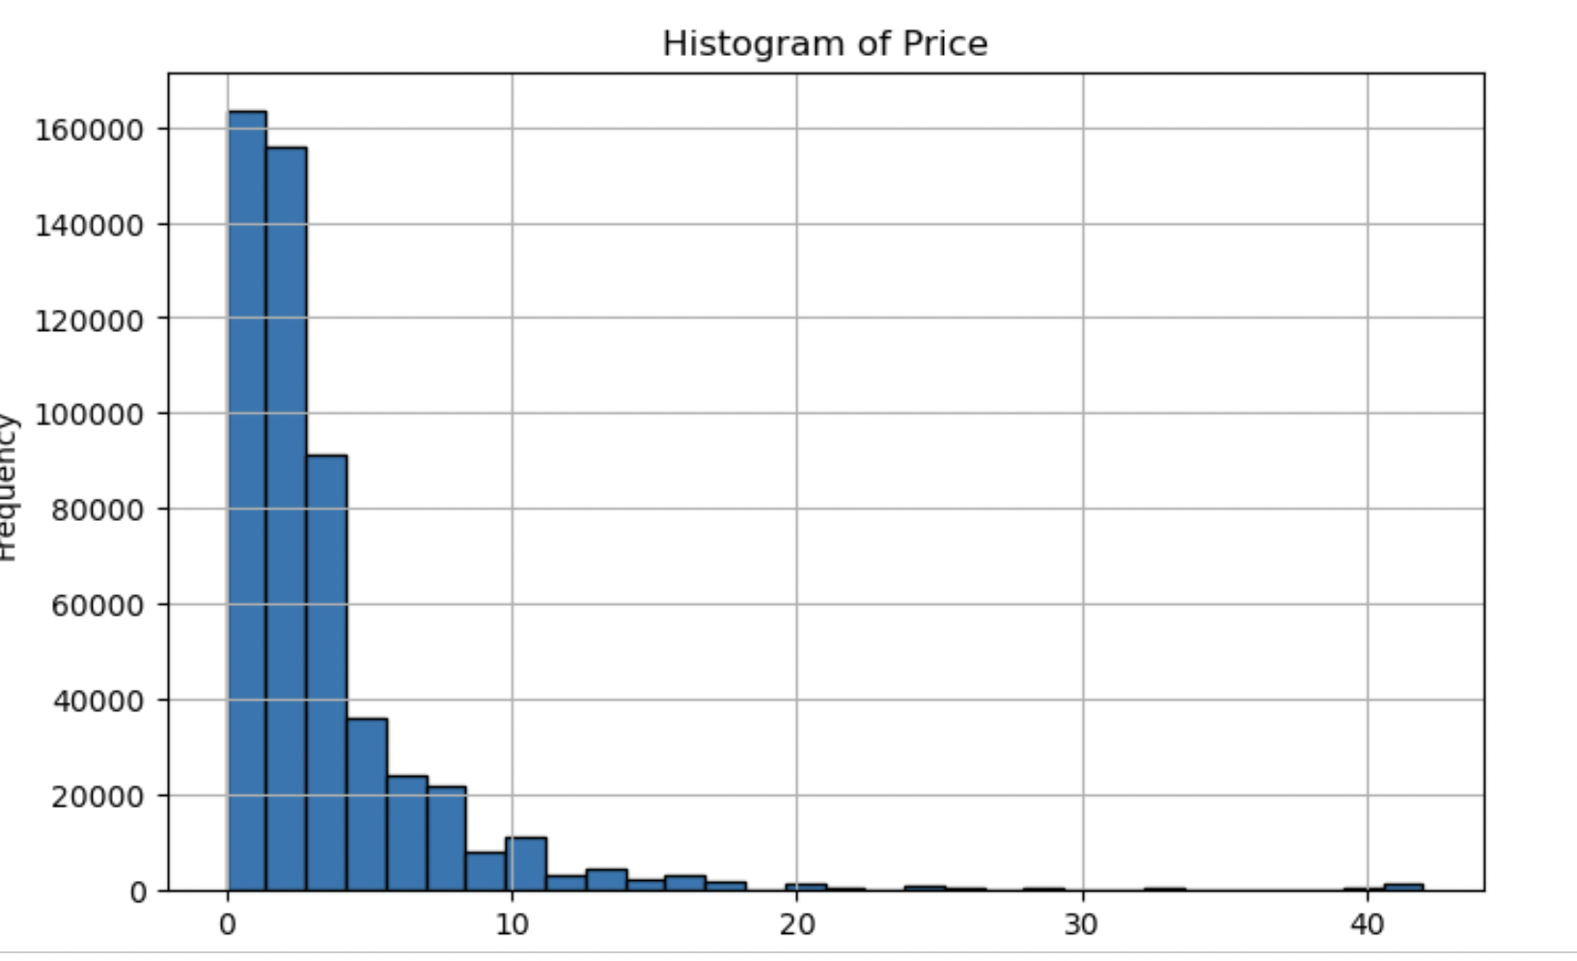

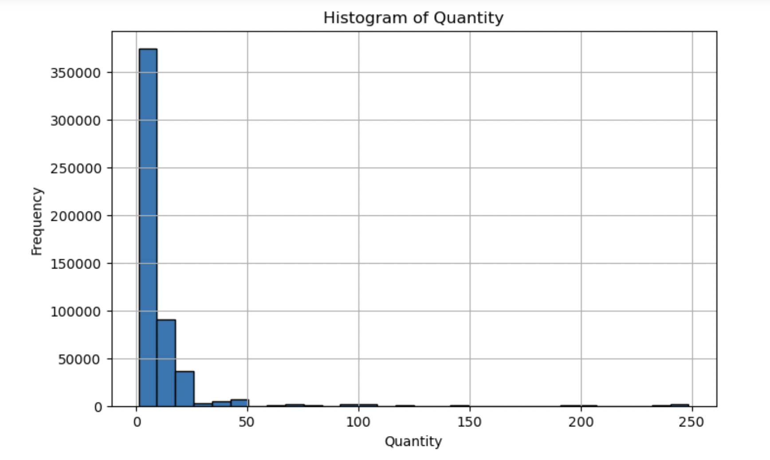

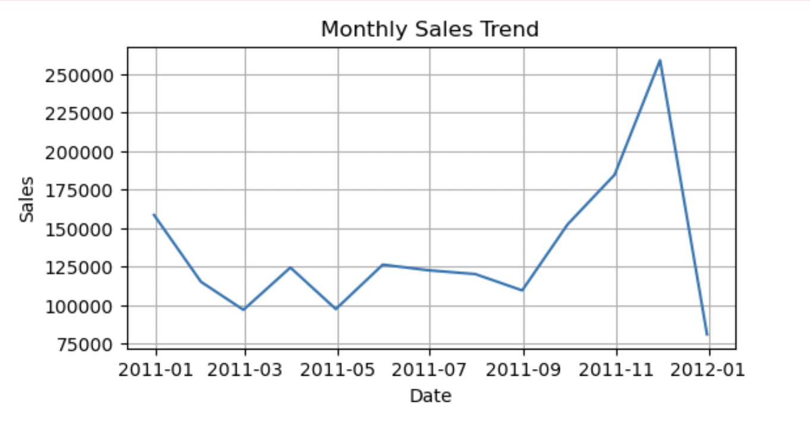

5. **Outlier detection and treatment**: play a crucial role in association rule mining. Identifying outliers is essential as they can distort the patterns and relationships discovered from the dataset. Once outliers are detected, appropriate measures need to be taken. Depending on the nature of the outliers, they can be either removed from the dataset or transformed using suitable techniques such as lower and upper limit of based on the 1st percentile (q1) and 99th percentile (q3) of the variable's values or logarithmic transformations. The interquartile range (iqr) is computed as the difference between q3 and q1. The multiplier factor of 1.5 is then applied to the iqr to determine the threshold range. Finally, the lower and upper limits are returned as a tuple.

Handling outliers effectively ensures more accurate and reliable association rule mining results, leading to better insights and decision-making in various domains and industries.

5.**Filtering irrelevant or noisy data**: is an important step in optimizing recommendation rules. Irrelevant or noisy data can introduce unwanted bias or distort the patterns discovered during association rule mining. To address this, filtering techniques are employed based on predefined criteria, such as a minimum support threshold. By setting appropriate thresholds, only frequent and significant patterns are retained, enhancing the quality and relevance of the recommendation rules. Removing irrelevant or noisy data ensures that the resulting rules are more meaningful, accurate, and useful in guiding decision-making processes for personalized recommendations.

6. **Handling negative quantities**: or returns is a critical aspect of recommendation systems. To address this, negative quantities can be filtered out or converted to positive values, ensuring consistency and accuracy in the recommendation process. Alternatively, negative quantities can be separated into distinct datasets, allowing for specific handling and analysis tailored to returns within the context of recommendations. The chosen approach depends on the specific requirements and objectives of the recommendation system being implemented.

Model Building:

**Model Building**: **Association Rule-Base Method**

The association rule-based technique is comprised of the following three essential components:

1)**. Gather association rules:** Apply association rule mining techniques (e.g., Apriori algorithm) to your transaction data to derive association rules. These rules represent patterns and associations between items based on their co-occurrence in user transactions.

2). **Generation of Frequent Itemsets**: The Apriori algorithm is a well-known technique that is utilized for this purpose. The Apriori algorithm is responsible for determining which item combinations occur frequently depending on their support. Support is defined as the percentage of total transactions that include a certain item combination. The algorithm performs an iterative exploration of the itemsets of varying lengths, beginning with a single item and progressively increasing the size of the itemsets until it reaches its maximum length. It removes itemsets from consideration if they fall short of the minimal support criterion, which ultimately leads to the formation of a collection of itemsets that are used frequently.

**Apriori Algorithm**:

a.Apriori Algorithm is a technique used for market basket analysis, which aims to discover associations between items that are frequently purchased together.

**Evaluation Metrics**:

1) Support(X, Y) = Freq(X, Y) / N

Support measures the probability of the co-occurrence of items X and Y in the transactions. It is calculated by dividing the frequency of transactions containing both X and Y by the total number of transactions.

2) Confidence(X, Y) = Freq(X, Y) / Freq(X)

Confidence measures the conditional probability of item Y being purchased given that item X is already purchased. It is calculated by dividing the frequency of transactions containing both X and Y by the frequency of transactions containing X.

3) Lift = Support(X, Y) / (Support(X) * Support(Y))

Lift quantifies the strength of the association between items X and Y. It compares the observed support of X and Y occurring together in comparison to what one would anticipate seeing if X and Y were independent statistically speaking. A lift value greater than 1 indicates a positive association, meaning the occurrence of item X increases the likelihood of item Y being purchased.

These metrics help in identifying meaningful associations between items in a dataset. By analyzing support, confidence, and lift values, one can uncover item associations that can be utilized for various purposes such as targeted marketing, product placement, or recommendation systems.

* In most cases, the "IF-THEN" pattern is utilized for writing association rules. We could also use the terms "Antecedent" for the left-hand side's "IF" and "Consequent" for the right-hand side "THEN."

a. **The Generation of Association Rules**: Association rules can be developed based on the frequent item sets that were collected by the Apriori technique. An antecedent, which is a group of things, is required for association rules, and a consequent, which might be a single thing or a group of things, is also required. These rules provide a representation of the connections between the things. Calculating metrics such as confidence and lift is an integral part of the process of generating association rules. Confidence is a measurement of how frequently the consequent item (or items) appear in transactions, including the antecedent item (or items), whereas lift is a measurement of how strongly the antecedent and consequent are associated with one another.

b. **Rule Evaluation and Selection**: The created rules are judged according to a wide range of different factors, such as support, confidence, and lift. For each of these indicators, thresholds are established in order to select the rules that are the most relevant and have the most influence. These carefully chosen guidelines serve as the foundation around which personalized recommendations are constructed.

5. **Generation of the Final Product**: the association rules have been established, the recommendation system will be able to create personalized recommendations for users. This method requires the following steps:

a. **User Profile Extraction**: Analyzing the user's history data to generate a profile that describes the user's interests, prior purchases, or interactions.

b. **Rule Matching**: Comparing the user's profile with the created association rules in order to locate relevant rules that match the user's preferences.

c. **Generation of Recommendations**: After the rules have been matched, the system will then produce a list of objects or activities that are suggested for the user to perform.

**1 . The Evaluation Matrix is after model building:**

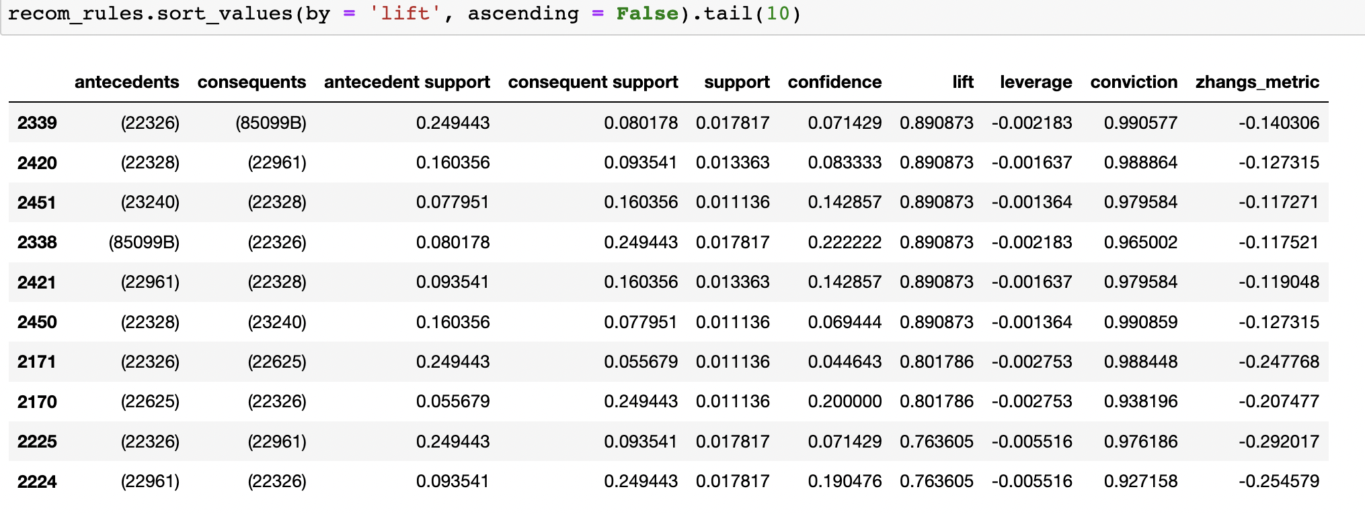

1. **Antecedents**: Antecedents are the items or itemsets that are found on the left-hand side of an association rule. Antecedents are also known as preconditions. They stand for the things or situations that are included in the dataset and are put to use in making predictions about the appearance of additional things or conditions.

2.**Consequents**: On the other hand, the items or item sets that are located on the right-hand side of an association rule are referred to as the consequents. They stand for the things or states that can be deduced to be the case based on the presence of the antecedents.

3. **Antecedent Support**: The antecedent support of a dataset is the proportion of transactions or instances that have the antecedent itemset. This can be thought of as the number of transactions or instances that have the antecedent itemset. It provides an indication of the frequency with which the antecedent itemset is found in the dataset.

4. **Consequent Support**: The proportion of the dataset's transactions or instances that contain the consequent itemset is referred to as the consequent support for this item. It is a representation of how frequently the succeeding itemset appears in the dataset as a whole.

5. **Support:** Support is the proportion of transactions or instances in the dataset that contain both the antecedent and consequent item sets. Support may be thought of as the ratio of antecedent to consequent items. It displays the general popularity or recurrence of the association rule by measuring the co-occurrence of the antecedent and consequent item sets and providing a measurement of this co-occurrence.

6. **Confidence**: Confidence can be defined as the conditional likelihood of discovering the consequent itemset in a transaction given that the antecedent itemset is present in the transaction. It determines how strong of a connection there is between the item sets that came before and those that came after them.

7. **Lift**: Lift is the ratio of the observed support to the predicted support if the antecedent and consequent were independent of each other. In other words, lift is the ratio of the observed support to the expected support. It gives an indication of how powerful and significant the association rule is. A lift that is more than 1 is indicative of a positive association, whereas a lift that is less than 1 is suggestive of a negative association.

8. **Leverage** The term "leverage" refers to a method of quantifying the difference between the actual assistance that was received and the support that would have been expected in the absence of any link. It determines how far one is from complete freedom.

9. **Conviction** The ratio of the expected confidence to the observed confidence is what constitutes conviction. If the antecedent and the consequent were unrelated to one another, then this ratio would be 1. It offers a metric that may be used to assess how dependent the consequent is on the antecedent.

10. **Zhang's** metre Zhang's metre is an evaluation metric for association rules that integrates lift and leverage into a single measurement. It offers a more in-depth and all-encompassing evaluation of the significance of the association rule by taking into consideration both the strength and the divergence from independence.

6. **Concluding remarks**:

A strategy that is adaptable and easy to read for the purpose of providing personalized recommendations is to construct a rule-based recommendation system utilizing the association rule-based method. Specifically, the Apriori algorithm should be utilized. Through the utilization of association rules, businesses are able to provide users with suggestions that are specific to their needs, hence improving the quality of the user experience and leading to higher levels of customer satisfaction. Importing relevant libraries, performing data preprocessing, utilizing the Apriori algorithm for frequent itemset generation, constructing association rules, and finally producing the finished product are all steps involved in the process. Incorporating additional data sources and making use of advanced algorithmic approaches to generate rules are also potential avenues for further improvement.

In conclusion, the rule-based recommendation system utilizing the association rule-based method that was provided in this research is a helpful tool for organizations that are looking to provide personalized recommendations to the users of their platforms. It is possible for businesses to make advantage of this strategy by first gaining a grasp of the concepts and actions involved in order to boost user engagement, increase sales, and improve overall customer happiness.